***Movie Recommendation System for Netflix Subscriber Using Content-Based Filtering Algorithm and Sentiment Analysis***

**Elaine S. Andus**Bachelor of Science in Computer Science

College of Science

elaine.andus@tup.edu.ph

**Joana, Marie L. Estrella**   
Bachelor of Science in Computer Science

College of Science

joanamarie.estrella@tup.edu.ph

***Abstract:* Today’s digital world is growing at a rapid rate over the past few years, so is the amount of data increasing enormously on the internet. Due to this, people find it difficult to choose the exact information they are looking for, or what certain movie they desire to watch next. Fret not, in this problem, recommendation system enters the picture. How to rapidly locate one’s favorite movie among a great number of choices has become a critical issue. Personalized recommendation system can play an important role especially when the user has no certain movie in mind. As a specific example, media service providers, such as Netflix, can improve their service by recommending desirable content to each user. In this paper the movie recommendation engine system aims to provide users with accurate movie recommendations based on the users’ previously watched films. The researchers design a movie recommendation engine system and implement a website application combined with the factors needed through content-based algorithm and sentiment analysis. Eventually, the test results showed that the system has worked and produced a high accuracy percentage.**

***Keywords:* Movie recommender, Content-based filtering algorithm, Netflix, Sentiment Analysis, Datasets**

1. **INTRODUCTION**
2. **REVIEW OF RELATED LITERATURE AND STUDIES**

This section presents various related literature and studies which are related to the researchers’ topic.   
There are many ways of recommending movies, these include using Content-based, Collaborative (User-item, User-user), context- based, hybrid methods, and nowadays deep learning is also used to solve the problem.

In [1] the study of C. S. M. Wu, D. Garg, and U. Bhandary with the research title of “Movie Recommendation System Using Collaborative Filtering”. The researchers’ proposed a recommendation system using collaborative filtering where a user’s rating is used to suggest the list. The

authors have used the Apache Mahout framework and essentially compared the performances and efficiency of user-based & item-based recommendations.

Retrieved from: <https://www.semanticscholar.org/paper/Movie-Recommendation-System-Using-Collaborative-Wu-Garg/1b2c2f2d9aa2e783664dae7ca8fdd89c1b9bf57b>

In [2] the study of R. E. Nakhli, H. Moradi, and M. A. Sadeghi with the research title of “Movie Recommender System Based on Percentage of View”. The researchers’ proposed the percentage view approach for recommending movies to the users, it finds relevant movies for the customer and then compares the performance with a random movie recommendation system for showing the accuracy of the project.

Retrieved from: <https://www.researchgate.net/publication/333762023_Movie_Recommender_System_Based_on_Percentage_of_View>

In [3] the study of H. W. Chen, Y. L. Wu, M. K. Hor, and C. Y. Tang with the research title of “Fully content-based movie recommender system with feature extraction using neural network” The researchers’ proposed method trains a neural network model, Word2Vec CBOW, with content information (e.g., cast, crew, etc.) as the training data to obtain vector form features of each element, and then take advantage of the linear relationship of learned feature to calculate the similarity between each movie. The researchers’ experiments are conducted on a massive real-world dataset, and the intuition behind the researchers’ proposed method has been proven by the experiment results

Retrieved from: <https://www.semanticscholar.org/paper/Fully-content-based-movie-recommender-system-with-Chen-Wu/cf0b84cd8f79b3dadbd14534723a15903b800b75>

In [4] the study of D.S Park, P. Vilakone and K. Xinchang with the research title “Movie Recommendation System Using k-clique and Association Rule Mining”. The researchers’ proposed a recommendation system using k-cliques and association rule mining. The researchers’ used the maximal clique method, to estimate the performance, then the researchers’ collaborative filtering methods are monitored using the k nearest neighbors, the k-clique method, and the k-clique and association rule mining are used to evaluate the researchers’ data.

Retrieved from: <https://hcis-journal.springeropen.com/articles/10.1186/s13673-018-0161-6>

In [5] the study of R. Nagamanjul, and A. Pethalakshmi with the research title “A Novel Scheme for Movie Recommendation System Using User Similarity and Opinion Mining”. The researchers’ proposed a movie recommender system based on new user similarity metric and opinion mining. The primary objective of this paper is to find the type of opinions (positive, negative, or neutral) for movies and suggest top-k recommendation list for users and extract aspect-based specific ratings from reviews and recommend reviews to users depends on user similarity and their rating patterns. Finally, validating the proposed movie recommendation system for various evaluation criteria, and the proposed system shows better result than conventional systems

Retrieved from: <https://www.ijitee.org/wp-content/uploads/papers/v8i4s2/D1S0071028419.pdf>

In [6] the study of J. Zhang, et al., with the research title “Personalized Real-Time Movie Recommendation System: Practical Prototype and Evaluation”. The researchers’ proposed a high-efficient recommendation algorithm, which exploits users’ profile attributes to partition them into several clusters. For each cluster, a virtual opinion leader is conceived to represent the whole cluster, such that the dimension of the original user item matrix can be significantly reduced, then a Weighted Slope One-VU method is designed and applied to the virtual opinion leader-item matrix to obtain the recommendation results. Compared to traditional clustering-based CF recommendation schemes, the researchers’ method can significantly reduce the time complexity, while achieving comparable recommendation performance.

Retrieved from: <https://ieeexplore.ieee.org/stamp/stamp.jsp?arnumber=8821512>

Most common ways used in implementation of movie recommender system is discussed below.

1. Content-based Filtering

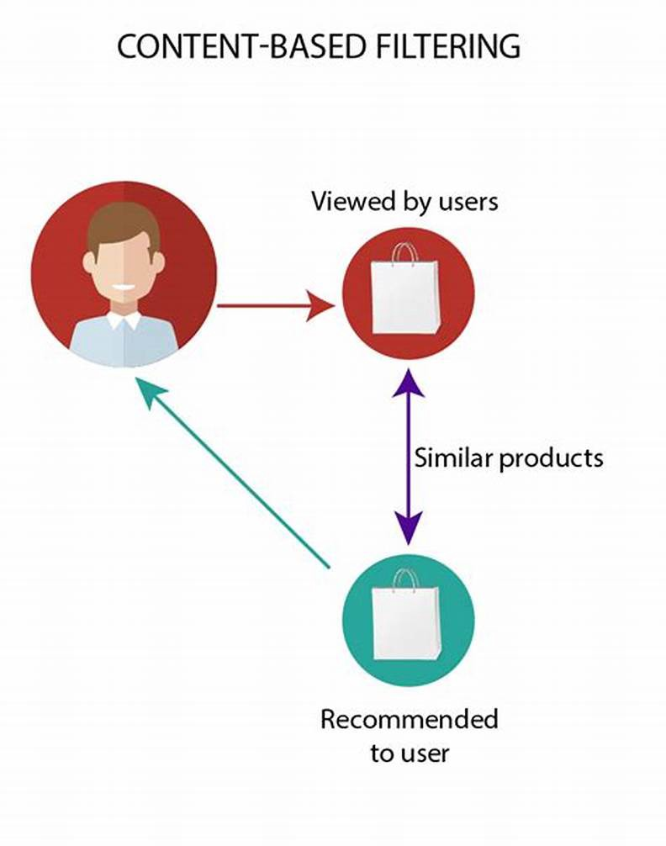This recommendation system requires some data or information on what the user might like or what his previous watched history. The figure 1 below explains the process.

**Figure 1:** Content-based filtering

1. Collaborative Filtering

Filters out the content according to user similar interest with other users, it basically recommends the items to users that have similar taste. It is also a popular and famous algorithm in the industries. The figure 2 below explains the process. Moreover, figure 3 and 4 discussed about the item-based and user-based collaborative filtering.

**Figure 2:** Collaborative filtering

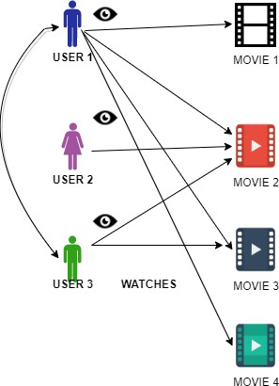

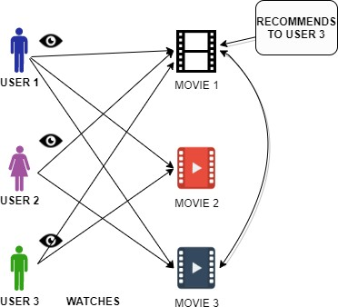**Figure 3:** Demonstration of User-Based CF

**Figure 4:** Demonstration of Item Based CF

In [Figure 3] the user-based, it is assumed that the user will like the items that are liked by users with whom they have similar tastes.

Consider Table 1 as an example, all the users like item A and people who like item A also like Item C, Item-based are not dynamic in nature and do not change.

**Table 1:** Item-Based CF

|  |  |  |  |
| --- | --- | --- | --- |
| **USER/ITEM** | **ITEM A** | **ITEM B** | **ITEM C** |
| **USER A** | ✔ |  | ✔ |
| **USER B** | ✔ | ✔ | ✔ |
| **USER C** | ✔ |  | Recommended |

In [Figure 4] the item-based, it is assumed that the user will like those items that are like the other items liked before. The hybrid approach – this approach provides very accurate results using both collaborative and content-based filtering while removing the drawbacks of the algorithms at the same time.

Eq. (1) is used to define the cosine similarity of the proposed model.

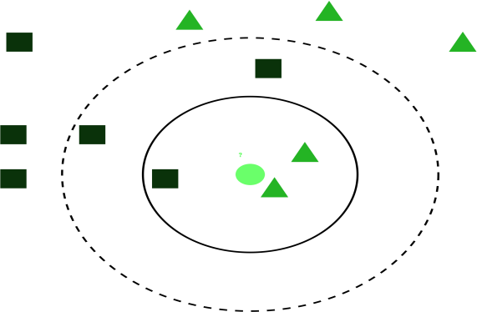

**Figure 4:** Demonstration of the K-NN algorithm (value of k=3) [5].

* 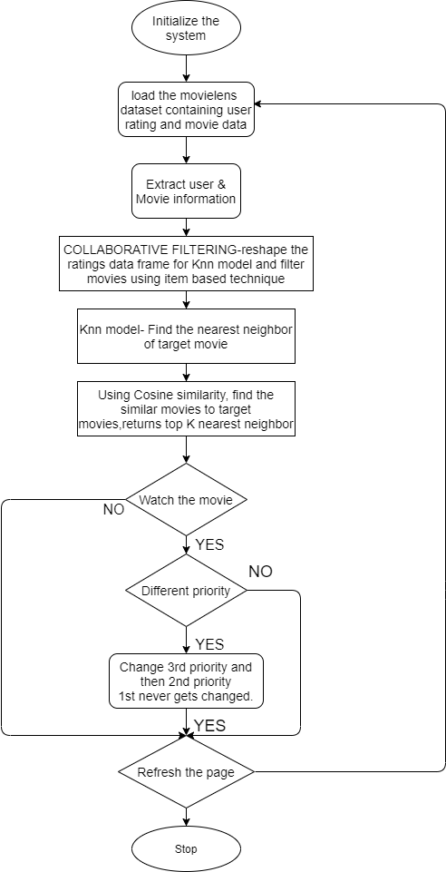**Item-based collaborative filtering**- assumes users will like items that are similar to the items that are liked before by the user.

1. **PRO PO SED REC O MMENDATIO N ENGINE**

The proposed recommendation system used the collaborative filtering technique (item-based approach) which is far more accurate and more efficient to use, as the item based method can be done offline and because of its non-dynamic nature whereas the user-based changes. The proposed approach uses the KNN algorithm to find the distance between the target movies with every other movie in the dataset and then it ranks the top k nearest similar movies using cosine angle similarity. Different techniques used in this proposed algorithm are discussed below:

* **KNN algorithm**- is famous in a recommendation system for its faster predictive nature and low calculation time. KNN [16] classifies any unlabeled class to their respective classes by prediction on a similarity measure as shown in figure 4.
* **Cosine similarity**- to calculate the distance between the target movie and the movies in the dataset, cosine similarity is used. It measures the similarity between two documents irrespective of how different they are in size, and calculates the cosine angle between two vectors in multi-dimensional space[6],

**Figure 5:** Proposed Collaborative filtering

Figure 5 shows the proposed collaborative filtering method. The objective here is to recommend movies using the item- based technique. First, the extraction of the dataset to gather information about the target movie and the user’s rating.

Second, the collaborative filtering begins with the formatting of the rating dataset so that it can be consumed by the KNN model, to remove the huge dataset handling problems . The dataset is reduced according to the popularity removing the noisy error pattern to get the sparse matrix.

Now cosine similarity is used to find the distance between the target movie and other movies, which gives us the top k nearest neighbor. And finally displaying the required recommended list of movies with descending order of distance

In the KNN algorithm, if the value of K=1, then the case is assigned to its nearest neighbor of that class. A case in KNN is classified by the most majority vote of its neighbors, where the case is being allocated to the class most common among its nearest neighbors measured by a distance function.

1. **IMPLEMENTATIO N**

Dataset Description- Movie lens dataset is used containing 28M ratings, over 1M tag application and 60k movies

# There is two input database:

1. Movies- containing movie-id, genres, title, user-id in Table 2
2. Rating- containing user-id, rating count, timestamp, movie-id in Table 3.

Filtering of the datasets is done on the basis only to popular ones by filtering the data frame to popular movies only.

**Table 2:** Movie.csv

|  |  |  |
| --- | --- | --- |
| **S. No** | **Movie Id** | **Title** |
| 0 | 1 | Toy Story (1995) |
| 1 | 2 | Jumanji (1995) |
| 2 | 3 | Grumpier Old Men (1995) |
| 3 | 4 | Waiting to Exhale (1995) |
| 4 | 5 | Father of the Bride Part II (1995) |

**Table 3:** Rating.csv

|  |  |  |  |
| --- | --- | --- | --- |
| **S.NO** | **USERID** | **MOVIEID** | **RATING** |
| 0 | 1 | 1 | 4.0 |
| 1 | 1 | 3 | 4.0 |
| 2 | 1 | 6 | 4.0 |
| 3 | 1 | 47 | 5.0 |
| 4 | 1 | 50 | 5.0 |

For data analysis, python libraries are used to analyze the movie dataset (as shown in figure 7) and to gain insight into the dataset that helped us in building the module. Every user has rated at least 20 movies. The use of pandas and NumPy and ScikitLearn, scipy libraries were for efficient results on Jupyter Notebook

python in this proposed approach. Every movie is rated in a range of 1 to 5(5 being the highest). Figure 6 shows, maximum rating of 3 and 4 for the movie in respect to other scores.

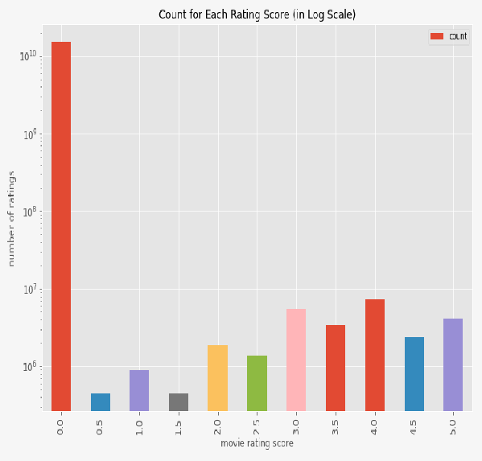

**Figure 6:** Count for each rating score

**import pandas as pd import NumPy as np**

**from scipy.sparse import** csr_matrix

**from sklearn.neighbors import** NearestNeighbors

**Figure 7:** Library used

As the dataset is huge and there can be where most of the movies are not rated or rated by only one, considering that, a sparse pivot matrix table is developed to transform the data frame into a proper data frame which can be further implemented by KNN and filing 0’s in missing information fields.[13]

The KNN analyses the pivot table and uses cosine similarity to find the similarity with the target movie and shows the result.

1. **CO NCLUSIO N**

In this paper, to avoid the use of content-based filtering, the Item-based CF filtering approach is used for obtaining better results. KNN collaborative recommendation system is proposed using cosine similarity by employing Movielens dataset containing 28M rating for over 60K movies. The existing system are compared and found that the proposed system is more reliable and accurate. It is also found that when the proposed methodology is applied to different larger datasets, both accuracy, and efficiency increase which proves that our system is both accurate and as well as efficient. This item-based filtering is more convenient than user-based. The main aim was to improve the regular recommendation algorithm and to provide better results. The research work was successful as it has been able to fulfill our aim of the project. In the future, more features can be included to datasets (year of release, actor, genre, casting details, etc) to make recommendations more reliable and innovative. The content- based filtering and collaborative filtering can be combined to minimize the errors and improve the performance as a hybrid approach.

**REFERENCES**

1. Bhandary U., Garg, M., D., and Wu, C. S., Movie Recommendation System Using Collaborative Filtering,” In *2018 IEEE 9th International Conference on Software Engineering and Service Science (ICSESS)*, pp. 11-15, IEEE, 2018 Nov.
2. Chen, H. W., Wu, Y. L., Hor, M. K., and Tang, C. Y., “Fully content- based movie recommender system with feature extraction using neural network,” In *2017 International Conference on Machine Learning and Cybernetics (ICMLC)*, vol. 2, pp. 504-509, July 2017, IEEE.
3. Indivar, S., Swapna, S. N., Trayabak, H., Srinivas N., K-means Clustering Algorithm Based on E-Commerce Big Data (2019). International Journal of Innovative Technology and Exploring Engineering (IJITEE) ISSN: 2278-3075, Volume-8 Issue-11, September 2019.
4. Jin, Q., Wang, Y., Yuan, Z., and Zhang, J., Personalized Real-Time Movie Recommendation System: Practical Prototype and Evaluation. TSINGHUA SCIENCE AND TECHNOLOGY ISSNll1007-0214 02/12 pp180–191 DOI: 1 0. 2 6 5 9 9/T ST. 2 0 1 8. 9 0 1 0 1 1 8 V olume 2 5, Number 2, April 2 0 2 0.
5. Nakhli, R. E., Moradi, H., and Sadeghi, M. A., “Movie Recommender System Based on Percentage of View,” In *2019 5th Conference on Knowledge Based Engineering and Innovation (KBEI)*, pp. 656-660, IEEE.
6. Park, DS., Vilakone, P., Xinchang, K. et al. An Efficient movie recommendation algorithm based on improved k-clique. Hum. Cent. Comput. Inf. Sci. 8, 38 (2018).
7. Pethalakshmi, A., and Nagamanjula, R., A Novel Scheme for Movie Recommendation System Using User Similarity and Opinion Mining. International Journal of Innovative Technology and Exploring Engineering (IJITEE) ISSN: 2278-3075, Volume-8 Issue-4S2 March 2019.
8. Sharma, P., and Yadav, L. Y., Movie Recommendation System Using Item Based Collaborative Filtering (2020). International Journal of Innovative Research in Computer Science & Technology (IJIRCST), ISSN: 2347-5552, Volume-8, Issue-4, July 2020.